Regions
AWS has the concept of a Region, which is a physical location around the world where we cluster data centers. We call each group of logical data centers an Availability Zone. Each AWS Region consists of multiple, isolated, and physically separate AZ's within a geographic area. Unlike other cloud providers, who often define a region as a single data center, the multiple AZ design of every AWS Region offers advantages for customers. Each AZ has independent power, cooling, and physical security and is connected via redundant, ultra-low-latency networks. AWS customers focused on high availability can design their applications to run in multiple AZ's to achieve even greater fault-tolerance. AWS infrastructure Regions meet the highest levels of security, compliance, and data protection.
AWS provides a more extensive global footprint than any other cloud provider, and to support its global footprint and ensure customers are served across the world,

AWS opens new Regions rapidly. AWS maintains multiple geographic Regions, including Regions in North America, South America, Europe, China, Asia Pacific, South Africa, and the Middle East.

Availability Zones
An Availability Zone (AZ) is one or more discrete data centers with redundant power, networking, and connectivity in an AWS Region. AZ’s give customers the ability to operate production applications and databases that are more highly available, fault tolerant, and scalable than would be possible from a single data center. All AZ’s in an AWS Region are interconnected with high-bandwidth, low-latency networking, over fully redundant, dedicated metro fiber providing high-throughput, low-latency networking between AZ’s. All traffic between AZ’s is encrypted. The network performance is sufficient to accomplish synchronous replication between AZ’s. AZ’s make partitioning applications for high availability easy. If an application is partitioned across AZ’s, companies are better isolated and protected from issues such as power outages, lightning strikes, tornadoes, earthquakes, and more. AZ’s are physically separated by a meaningful distance, many kilometers, from any other AZ, although all are within 100 km (60 miles) of each other.

North America
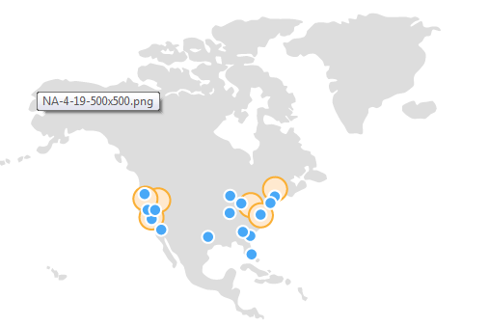
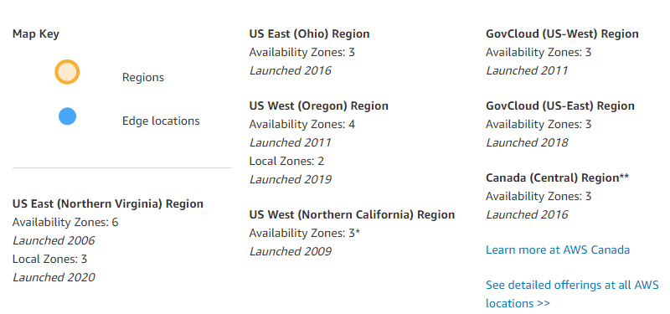

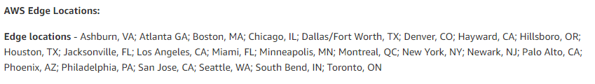

South America

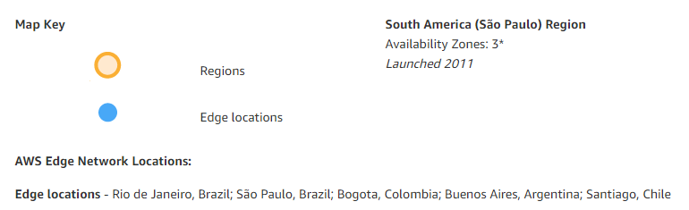
Europe/Middle East/ Africa
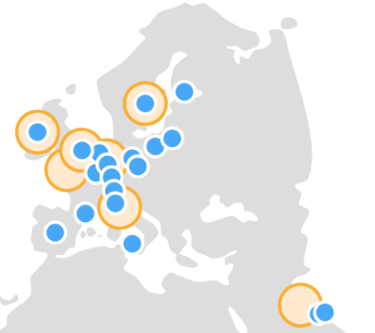
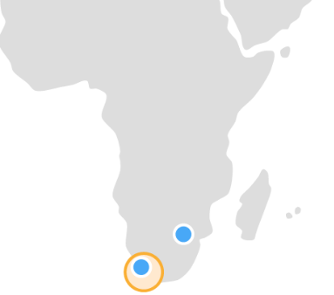
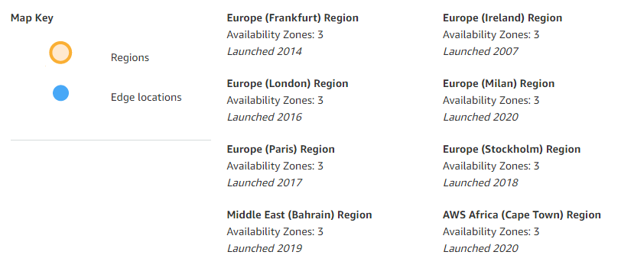
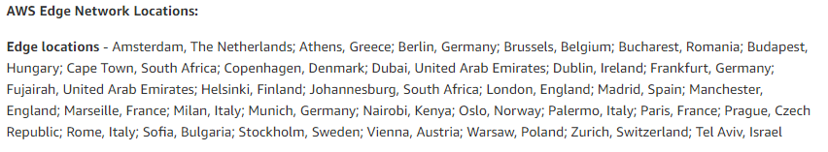
Asia Pacific
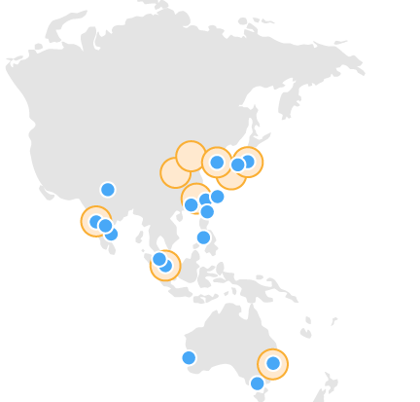
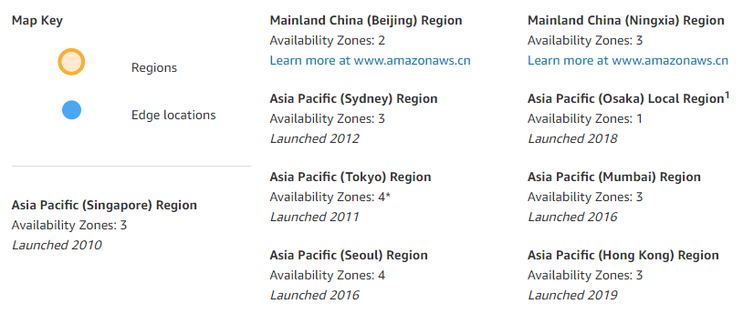

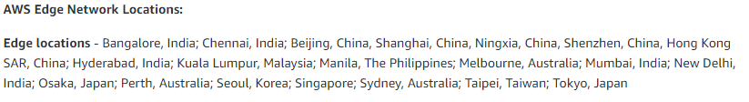

Types of status checks
There are two types of status checks: system status checks and instance status checks.

System status checks
System status checks monitor the AWS systems on which your instance runs. These checks detect underlying problems with your instance that require AWS involvement to repair. When a system status check fails, you can choose to wait for AWS to fix the issue, or you can resolve it yourself. For instances backed by Amazon EBS, you can stop and start the instance yourself, which in most cases results in the instance being migrated to a new host. For instances backed by instance store, you can terminate and replace the instance.
The following are examples of problems that can cause system status checks to fail:
- Loss of network connectivity
- Loss of system power
- Software issues on the physical host
- Hardware issues on the physical host that impact network reachability

Instance status checks
Instance status checks monitor the software and network configuration of your individual instance. Amazon EC2 checks the health of the instance by sending an address resolution protocol (ARP) request to the network interface (NIC). These checks detect problems that require your involvement to repair. When an instance status check fails, you typically must address the problem yourself (for example, by rebooting the instance or by making instance configuration changes).
The following are examples of problems that can cause instance status checks to fail:
- Failed system status checks
- Incorrect networking or startup configuration
- Exhausted memory
- Corrupted file system
- Incompatible kernel

What is Amazon VPC?

Amazon Virtual Private Cloud (Amazon VPC) enables you to launch AWS resources into a virtual network that you've defined. This virtual network closely resembles a traditional network that you'd operate in your own data center, with the benefits of using the scalable infrastructure of AWS.
The following are the key concepts for VPCs:
- Virtual private cloud (VPC) — A virtual network dedicated to your AWS account.
- Subnet — A range of IP addresses in your VPC.
- Route table — A set of rules, called routes, that are used to determine where network traffic is directed.
- Internet gateway — A gateway that you attach to your VPC to enable communication between resources in your VPC and the internet.
- VPC endpoint — enables you to privately connect your VPC to supported AWS services and VPC endpoint services powered by PrivateLink without requiring an internet gateway, NAT device, VPN connection, or AWS Direct Connect connection. Instances in your VPC do not require public IP addresses to communicate with resources in the service. Traffic between your VPC and the other service does not leave the Amazon network.
- CIDR block —Classless Inter-Domain Routing. An internet protocol address allocation and route aggregation methodology.

- A VPC with a size /16 IPv4 CIDR block (example: 10.0.0.0/16). This provides 65,536 private IPv4 addresses.
- A public subnet with a size /24 IPv4 CIDR block (example: 10.0.0.0/24). This provides 256 private IPv4 addresses. A public subnet is a subnet that's associated with a route table that has a route to an Internet gateway.
- A private subnet with a size /24 IPv4 CIDR block (example: 10.0.1.0/24). This provides 256 private IPv4 addresses.
- An Internet gateway. This connects the VPC to the Internet and to other AWS services.

VPC peering
A VPC peering connection is a networking connection between two VPCs that enables you to route traffic between them privately. Instances in either VPC can communicate with each other as if they are within the same network. You can create a VPC peering connection between your own VPCs, with a VPC in another AWS account, or with a VPC in a different AWS Region.
AWS uses the existing infrastructure of a VPC to create a VPC peering connection; it is neither a gateway nor an AWS Site-to-Site VPN connection, and does not rely on a separate piece of physical hardware. There is no single point of failure for communication or a bandwidth bottleneck.

A public subnet has an outbound route that sends all traffic through what AWS calls an Internet Gateway (IGW). The IGW lets traffic — IPv4 or IPv6 — out of the VPC without any constraints on bandwidth. Instances in public subnets can also receive inbound traffic through the IGW as long as their security groups and Network ACLs allow it.
Contrast that with a private subnet which, if it needs to talk to the internet, must do so through a Network Address Translation (NAT) gateway. NATs are really common. Run a wireless router? The router itself does network address translation. Importantly a NAT won’t allow inbound traffic from the internet — that’s what makes a private subnet, well, private.
AWS has its own managed NAT Gateway offering for outbound IPv4 traffic and an egress-only IGW for IPv6 traffic.
The difference between a public and private subnet? A public subnet has a route table that says, “send all outbound traffic (anything to the CIDR block 0.0.0.0/0) via this internet gateway.” A private subnet either does not allow outbound traffic to the internet or has a route that says, “send all outbound traffic via this NAT gateway.”
It’s important to note that all subnets in a VPC can talk to one another as long as the host’s security groups allow it. There’s always a route that says “keep traffic to {YourVPCsCIDRblock} inside the VPC.”

A private subnet sets that route to a NAT instance. Private subnet instances only need a private ip and internet traffic is routed through the NAT in the public subnet. You could also have no route to 0.0.0.0/0 to make it a truly private subnet with no internet access in or out.
A public subnet routes 0.0.0.0/0 through an Internet Gateway (igw). Instances in a public subnet require public IPs to talk to the internet.

Application Load Balancer vs Classic Load Balancer

A load balancer accepts requests for your application and distributes them to different servers which run your Rails application. The load balancer is the entry point of all requests so it's important that this is always up and running. An AWS load balancer is managed by AWS and is highly available and reliable.

In general, a load balancer can operate on the request level (Layer 7) or the connection level (Layer 4). At the connection level, we deal with lower level protocols like TCP and UDP. The load balancer doesn't know whether it is distributing HTTP requests or something else.
At the request level, we deal with higher level protocols like HTTP. On this level, the load balancer knows that your user requested for a particular host (e.g. example.com) and a path (/images/logo.png). This is required if you need advanced routing rules that depend on the host and path.

The Classic Load Balancer operates on both the request and connection levels. However, it doesn't support features like host and path based routing. This is the first load balancer that AWS introduced in 2009 so it is missing some features. The Application Load Balancer was introduced to address this. A Classic Load Balancer is recommended only for EC2 Classic instances.
The Application Load Balancer operates at the request level only. If you're dealing with HTTP requests, which you are for your web application, you can use this. It supports the basic feature of distributing requests using the round robin algorithm. It also supports advanced features like host and path based routing.
Let's take a look at how to set up these features on an Application Load Balancer. An Application Load Balancer consists of Listeners, Rules, Target Groups.

Listener
An Application Load Balancer has one or more listeners. A listener has a protocol (HTTP or HTTPS) and a port (1-65535). For web applications, you normally use a listener for HTTP on port 80 and HTTPS on port 443. These are for requests to the http and https versions of your site. If you can, redirect all http requests to https. You need to do this on your servers because you can't do this on the AWS load balancers. But this is another topic.

Rule
Each listener has a default rule which you can't delete. This is for the basic feature of distributing all requests to the different servers.
You can also define additional rules. These can be rules to support host and path based routing. Since an Application Load Balancer operates on the HTTP level, it can see the HTTP requests complete with headers (e.g. example.com/images/logo.png).
You can add a rule for the host example.com and forward the requests to a specific set of servers. You can also add a rule for the path /images/* and forward the requests accordingly.
These rules allow you to do advanced routing that otherwise aren't supported on a Classic Load Balancer.

Target Group
Each rule has a target group. This is the group of registered targets where requests are distributed to. A target can either be an EC2 instance or an IP address.
You can register a target to multiple target groups which allows you to use more advanced configuration. You can also register an EC2 instance or an IP address with the same target group multiple times using different ports. This is done to support load balancing to microservices.

Difference between EBS and Instance Store
EBS volume is network attached drive which results in slow performance but data is persistent meaning even if you reboot the instance data will be there.
Instance store instance store provides temporary block-level storage for your instance. This storage is located on disks that are physically attached to the host computer.
Instance Store

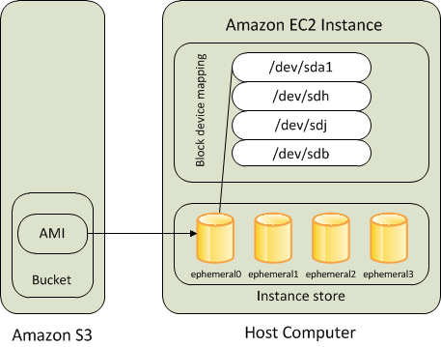
- Instance store backed instance is an EC2 instance using an Instance store as root device volume created from a template stored in S3.
- An instance store is ephemeral storage that provides temporary block level storage for your instance. Instance store is ideal for temporary storage like buffers, caches, and other temporary content.
- Instance store volumes accesses storage from disks that are physically attached to the host computer.
- When an Instance stored instance is launched, the image that is used to boot the instance is copied to the root volume (typically sda1).
- Instance store provides temporary block-level storage for instances.
- Data on an instance store volume persists only during the life of the associated instance; if an instance is stopped or terminated, any data on instance store volumes is lost.

Amazon Elastic Block Store (EBS)

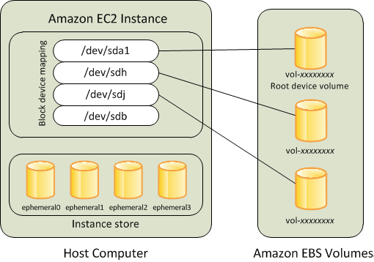
- An “EBS-backed” instance means that the root device for an instance launched from the AMI is an EBS volume created from an EBS snapshot
- An EBS volume behaves like a raw, unformatted, external block device that can be attached to a single instance and are not physically attached to the Instance host computer (more like a network attached storage).
- Volume persists independently from the running life of an instance. After an EBS volume is attached to an instance, you can use it like any other physical hard drive.
- EBS volume can be detached from one instance and attached to another instance.
- EBS volumes can be created as encrypted volumes using the EBS encryption feature.
- EBS is block store which is separately attached to EC2. Also its design such a way that it will be replicated within its availability zone so it provides high availability and durability.
- And the additional advantage of it is, you can have back-ups for EBS by creating Snapshots which is not possible instance store. So that whenever you want to retrieve the data you can just create the EBS volume from the snapshot.

Amazon EC2 Auto Scaling
Amazon EC2 Auto Scaling helps you ensure that you have the correct number of Amazon EC2 instances available to handle the load for your application. You create collections of EC2 instances, called Auto Scaling groups. You can specify the minimum number of instances in each Auto Scaling group, and Amazon EC2 Auto Scaling ensures that your group never goes below this size. You can specify the maximum number of instances in each Auto Scaling group, and Amazon EC2 Auto Scaling ensures that your group never goes above this size. If you specify the desired capacity, either when you create the group or at any time thereafter, Amazon EC2 Auto Scaling ensures that your group has this many instances. If you specify scaling policies, then Amazon EC2 Auto Scaling can launch or terminate instances as demand on your application increases or decreases.
AWS Auto Scaling enables you to configure automatic scaling for the AWS resources that are part of your application in a matter of minutes. The AWS Auto Scaling console provides a single user interface to use the automatic scaling features of multiple AWS services. You can configure automatic scaling for individual resources or for whole applications.
With AWS Auto Scaling, you configure and manage scaling for your resources through a scaling plan. The scaling plan uses dynamic scaling and predictive scaling to automatically scale your application's resources. This ensures that you add the required computing power to handle the load on your application and then remove it when it's no longer required. The scaling plan lets you choose scaling strategies to define how to optimize your resource utilization. You can optimize for availability, for cost, or a balance of both. Alternatively, you can create custom scaling strategies.
AWS Auto Scaling is useful for applications that experience daily or weekly variations in traffic flow, including the following:
- Cyclical traffic such as high use of resources during regular business hours and low use of resources overnight
- On and off workload patterns, such as batch processing, testing, or periodic analysis
- Variable traffic patterns, such as marketing campaigns with periods of spiky growth

For example, the following Auto Scaling group has a minimum size of one instance, a desired capacity of two instances, and a maximum size of four instances. The scaling policies that you define adjust the number of instances, within your minimum and maximum number of instances, based on the criteria that you specify.
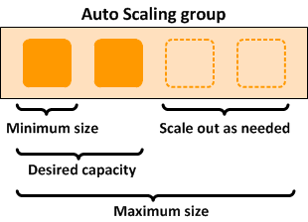

key components of Amazon EC2 Auto Scaling-

Groups
Your EC2 instances are organized into groups so that they can be treated as a logical unit for the purposes of scaling and management. When you create a group, you can specify its minimum, maximum, and, desired number of EC2 instances.

Configuration templates
Your group uses a launch template, or a launch configuration (not recommended, offers fewer features), as a configuration template for its EC2 instances. You can specify information such as the AMI ID, instance type, key pair, security groups, and block device mapping for your instances.

Scaling options
Amazon EC2 Auto Scaling provides several ways for you to scale your Auto Scaling groups. For example, you can configure a group to scale based on the occurrence of specified conditions (dynamic scaling) or on a schedule.

On-Demand Instances
With On-Demand Instances, you pay for compute capacity by the second with no long-term commitments. You have full control over its lifecycle—you decide when to launch, stop, hibernate, start, reboot, or terminate it.
There is no long-term commitment required when you purchase On-Demand Instances. You pay only for the seconds that your On-Demand Instances are in the running state. The price per second for a running On-Demand Instance is fixed.
https://docs.aws.amazon.com/AWSEC2/latest/UserGuide/ec2-on-demand-instances.html
Reserved Instances
Reserved Instances provide you with significant savings on your Amazon EC2 costs compared to On-Demand Instance pricing. Reserved Instances are not physical instances, but rather a billing discount applied to the use of On-Demand Instances in your account. These On-Demand Instances must match certain attributes, such as instance type and Region, in order to benefit from the billing discount.
Savings Plans also offer significant savings on your Amazon EC2 costs compared to On-Demand Instance pricing. With Savings Plans, you make a commitment to a consistent usage amount, measured in USD per hour. This provides you with the flexibility to use the instance configurations that best meet your needs and continue to save money, instead of making a commitment to a specific instance configuration.

- RDS offers two ways to store data- manually and automatically
- While working with RDS you do come across an option known as Backup, it is the place where you can protect your data, you can specify backup storage duration from 0–35 days
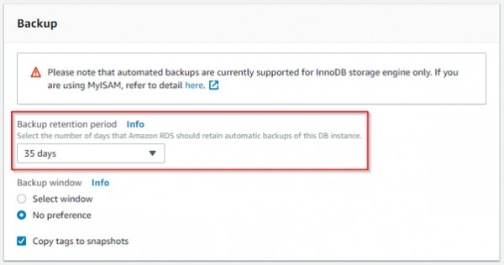
- For manual data storage you can make use of Snapshots. On creating snapshots even if you delete the root DB instance the data still exists till you manually delete the created Snapshot
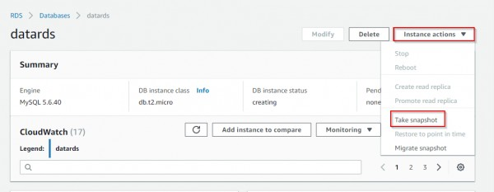

AWS Application Load Balancer algorithms
Until November 2019, AWS Application Load Balancers (ALBs) only supported the round-robin algorithm. Now, we can use the Least Outstanding Requests (LOR) algorithm,

Round-Robin
The round-robin algorithm is the simplest. It cycles through your targets in order, so each target should receive an equal share of requests. Due to its simplicity, all load balancers support the round-robin algorithm.
Below is a diagram showing how the round-robin algorithm directs requests. It shows the service scaling up from 5 tasks to 6, after which the new task starts receiving an equal share of the traffic — 1/6th.

Diagram showing which task receives each request when using the round-robin algorith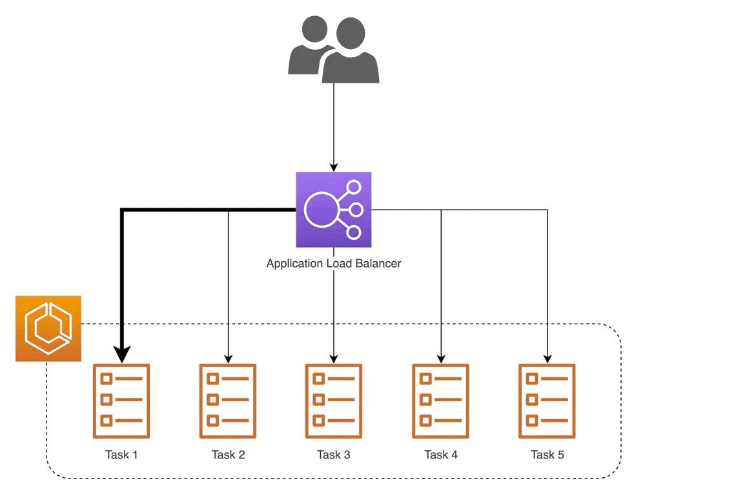m

Round-robin pros + cons
- ✅ Simple and easy to understand
- ✅ Each target receives an even split of traffic
- ❌ Targets need to be the same size and have similar performance
- ❌ Requests should all be similar in load + latency
The last point, that requests should be similar in load + latency, is the most important problem. APIs usually allow many request methods, each of which will result in a different amount of load. For example, a POST request will usually take much more processing than a GET request.
Looking at the diagram above, Task 1 could still be processing the previous request by the time it receives another one. Task 2 might be running on slower hardware. When using cloud resources, it’s impossible to guarantee the same performance for each instance. Even worse, if we’re using a spot fleet, we’ll have different instance sizes running, each of which with varying performance and capacity.

Least Outstanding Requests
The Least Outstanding Requests (LOR) algorithm aims to solve these issues. Instead of cycling through your targets, it’ll select the target with the lowest number of requests waiting for responses. NGINX refers to this algorithm as least_conn.
This diagram shows how the LOR algorithm directs requests. We start with some outstanding requests and, for simplicity, imagine that no requests are finishing — otherwise the number of outstanding requests (OR) would increase and decrease.

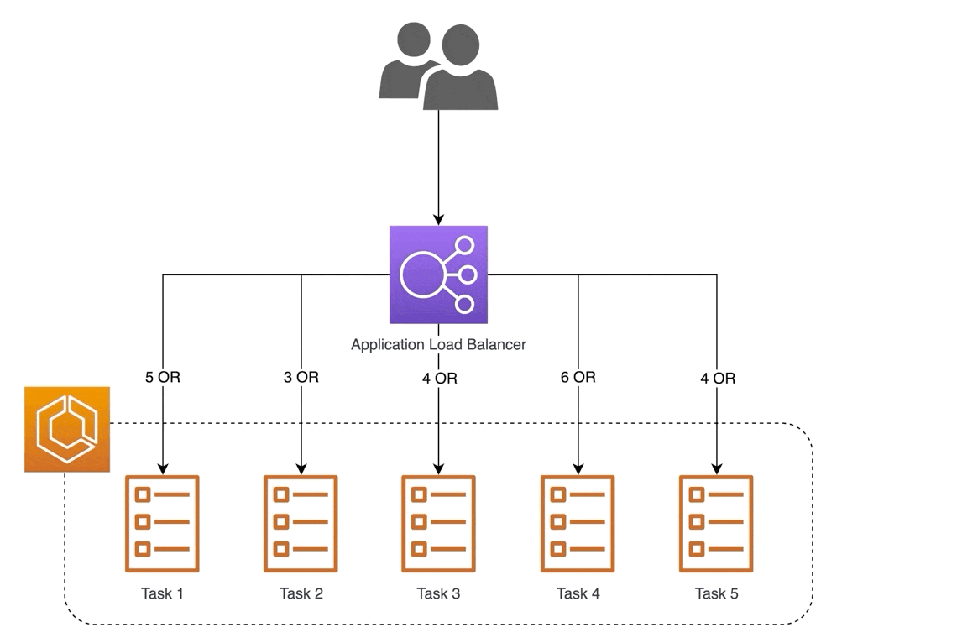
Diagram showing which task receives each request when using the Least Outstanding Requests algorithm
When Task 6 joins the target group, it receives all new requests until the cluster is balanced.

Connect to another EC2 with having only private IP from one EC2 instance
  - Create a new file with any name and copy the .pem file contents to it.

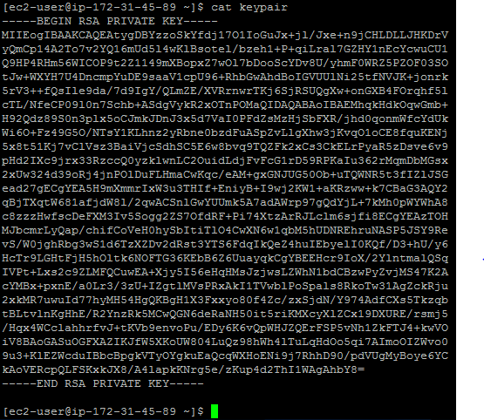
Run below command
ssh -i keypair ec2-user@172.31.35.39
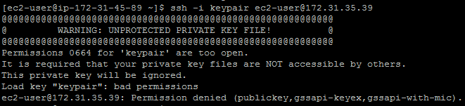
If you see above error run below command and then try again
[ec2-user@ip-172-31-45-89 ~]$ chmod 600 keypair
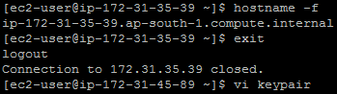

Identity-based policies and resource-based policies
PDF
Kindle
RSS
A policy is an object in AWS that, when associated with an identity or resource, defines their permissions. When you create a permissions policy to restrict access to a resource, you can choose an identity-based policy or a resource-based policy.
Identity-based policies are attached to an IAM user, group, or role. These policies let you specify what that identity can do (its permissions). For example, you can attach the policy to the IAM user named John, stating that he is allowed to perform the Amazon EC2 RunInstances action. The policy could further state that John is allowed to get items from an Amazon DynamoDB table named MyCompany. You can also allow John to manage his own IAM security credentials. Identity-based policies can be managed or inline.
Resource-based policies are attached to a resource. For example, you can attach resource-based policies to Amazon S3 buckets, Amazon SQS queues, and AWS Key Management Service encryption keys. For a list of services that support resource-based policies, see AWS services that work with IAM.
With resource-based policies, you can specify who has access to the resource and what actions they can perform on it. To learn whether principals in accounts outside of your zone of trust (trusted organization or account) have access to assume your roles, see What is IAM Access Analyzer?. Resource-based policies are inline only, not managed.
Note
Resource-based policies differ from resource-level permissions. You can attach resource-based policies directly to a resource, as described in this topic. Resource-level permissions refer to the ability to use ARNs to specify individual resources in a policy. Resource-based policies are supported only by some AWS services. For a list of which services support resource-based policies and resource-level permissions, see AWS services that work with IAM.
AWS Route 53 Routing Policy types

When you create a record, you choose a routing policy, which determines how Amazon Route 53 responds to queries:
- Simple routing policy — Use for a single resource that performs a given function for your domain, for example, a web server that serves content for the example.com website.
- Weighted routing policy — Use to route traffic to multiple resources in proportions that you specify.
- Latency routing policy — Use when you have resources in multiple AWS Regions and you want to route traffic to the region that provides the best latency.
- Failover routing policy — Use when you want to configure active-passive failover.
- Geolocation routing policy — Use when you want to route traffic based on the location of your users.
- Geoproximity routing policy — Use when you want to route traffic based on the location of your resources and, optionally, shift traffic from resources in one location to resources in another.
- Multivalue answer routing policy — Use when you want Route 53 to respond to DNS queries with up to eight healthy records selected at random.
- Simple Routing Policy
- 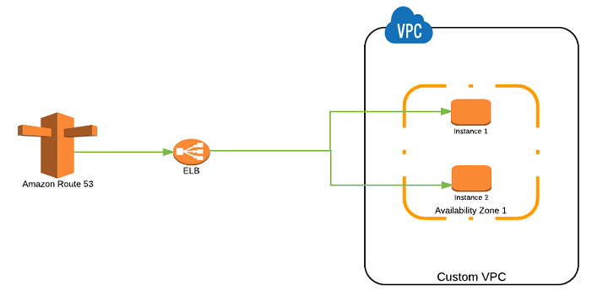
- Amazon Route 53 — Simple Routing Policy
- Simple Routing Policy is the most basic routing policy defined using an A record to resolve to a single resource always without any specific rules. For instance, a DNS record can be created to resolve the domain to an ALIAS record that routes the traffic to an ELB load balancing a set of EC2 instances.

- Weighted Routing Policy
- 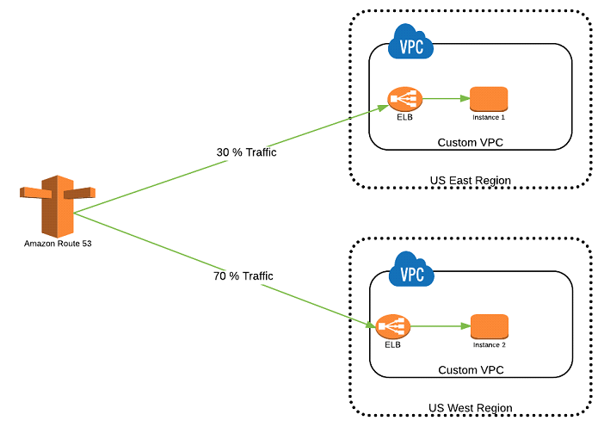
- Amazon Route 53 — Weighted Routing Policy
- Weighted Routing Policy is used when there are multiple resources for the same functionality and the traffic needs to be split across the resources based on some predefined weights.
- Latency Routing Policy
- 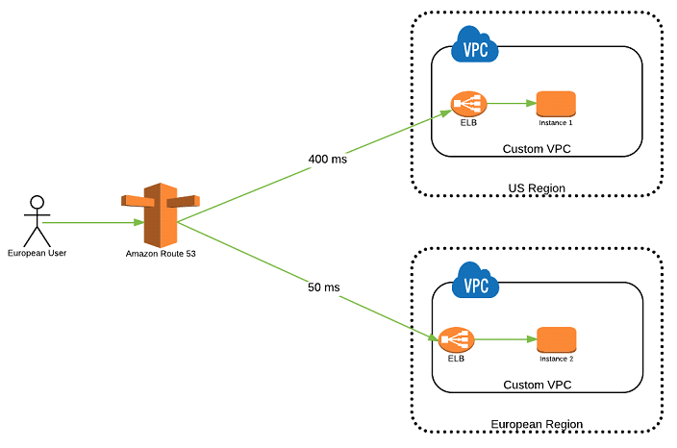
- Amazon Route 53 — Latency Routing Policy
- Latency Routing Policy is used when there are multiple resources for the same functionality and you want Route 53 to respond to DNS queries with answers that provide the best latency i.e. the region that will give the fastest response time.

- Failover Routing Policy
- 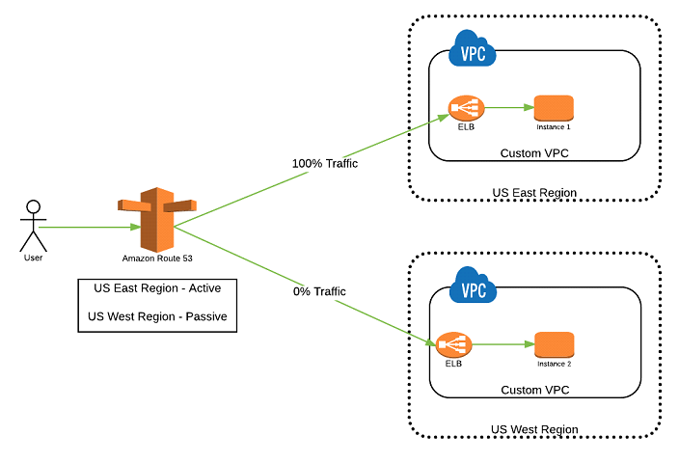
- Amazon Route 53 — Failover Routing Policy
- Failover Routing Policy is used to create Active/Passive set-up such that one of the site is active and serve all the traffic while the other Disaster Recover (DR) site remains on the standby. Route 53 monitors the health of the primary site using the health check.
- Geolocation Routing Policy
- 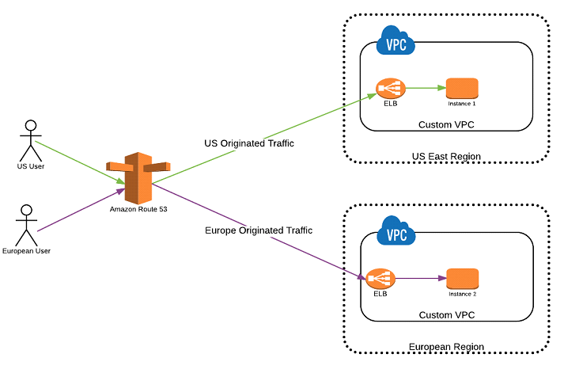
- Amazon Route 53 — Geolocation Routing Policy
- Geolocation Routing Policy is used to route the traffic based on the geographic location from where the DNS query is originated. This policy allows to send the traffic to resources in the same region from where the request was originated i.e. it allows to have site affinity based on the location of the users.
Amazon Web Services (AWS) lets you set up disaster recovery, both for on-premise services, and for workloads deployed in the Amazon cloud.
AWS offers four main disaster recovery (DR) strategies you can leverage to create backups and replicas that are available during disaster events. Each strategy has progressively higher cost and complexity, but lower recovery times:
- Backup and restore – involves backing up your systems and restoring them from backup in case of disaster.
- Pilot light – involves running core services in standby mode, and triggering additional services as needed in case of disaster.
- Warm standby – involves running a full backup system in standby mode, with live data replicated from the production environment.
- Multi-site active/active – running a full, secondary production system, ready to serve traffic when needed.
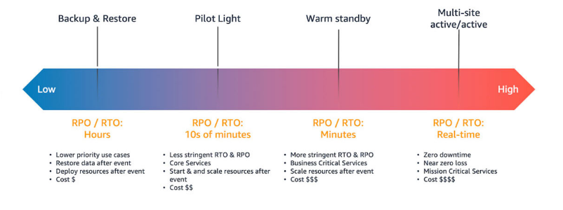

DR Strategies on AWS and their Recovery Point Objective and Recovery Time Objective
When planning your disaster recovery strategy on AWS, consider your recovery time objective (RTO) and recovery point objective (RPO), as illustrated in the image below:
- Recovery Time Objective (RTO) is the longest delay the business can tolerate between the disaster event and continuation of services.
- Recovery Point Objective (RPO) is the longest time that may pass since the last backup window. For example, if the organization backs up files once per hour, at most the organization can lose one hour of data, the RPO is 60 minutes.

